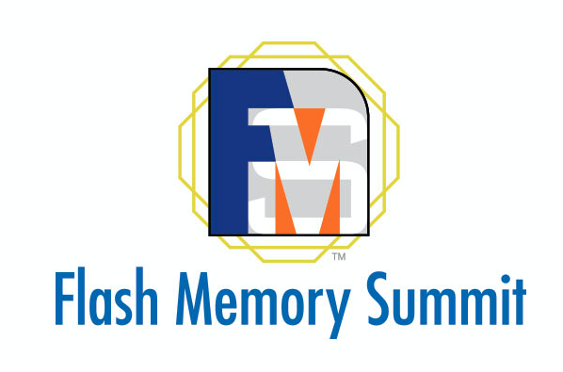

Storage for AI/ML Applications Plays a Key Role at Flash Memory Summit 2020

Data analytics, deep learning, and other AI/ML applications drive
multi-billion-dollar flash memory market

SANTA CLARA, CA – OCTOBER 1, 2020 – Virtual Flash Memory Summit (FMS), the world’s premiere flash memory conference and exposition, announces a major program track on Storage for Artificial Intelligence and Machine Learning (AI/ML) Applications.

The new track features talks on storage strategies, model training, workloads, NVMe and logical volumes, persistent memory, software-defined architectures, and accelerating the GPU data path. It also includes panels on model scalability and long-term horizons, plus a keynote by Geoffrey Burr, Distinguished Researcher at IBM Almaden Research Center. Virtual Flash Memory Summit 2020 will be held on November 10-12 and expects to draw more than 6,000 attendees.
AI/ML applications require vast amounts of low latency, high-throughput flash storage. Cloud and enterprise data center architectures must be optimized to train deep neural networks and analyze petabyte-scale datasets, all while satisfying critical cost constraints.
The rapid adoption of AI/ML applications is fueling tremendous growth in demand for flash memory. According to IDC, the combined flash memory and SSD (Solid State Drive) markets will grow to almost $90 billion in 2022¹.
"AI/ML is the fastest-growing application in data centers today,” said Chuck Sobey, Conference Chairperson for Flash Memory Summit. "Advances like persistent memory, computational storage, QLC technology, and emerging non-volatile memories must be combined with rapid progress in 3D NAND flash to meet the needs of AI/ML for more data, faster.”
Now in its 15th year, Flash Memory Summit features the latest technology trends, the most innovative products, and the broadest coverage of this rapidly expanding market. In 2019, FMS drew over 6,000 registrants and over 120 exhibitors. The conference also features marketing and market research sessions plus sessions sponsored by NVM Express®, SNIA, and TechTarget, as well as a full-day free track by IDC on the latest market research. Popular continuing features include annual updates and industry trends and overviews.
Supporting Resources
- Visit FMS: FlashMemorySummit.com
- Follow FMS on LinkedIn.com/groups/4129499
- Follow FMS on Twitter.com/FlashMem
- Follow FMS on Facebook.com/FlashMemorySummit
To discuss sponsoring and exhibiting, contact:
- Kat Pate, Vice President of Sales
Kat@FlashMemorySummit.com
+1.505.238.3208

To ask about the program, contact:
- Lance Leventhal, Program Chairperson
Lance@FlashMemorySummit.com
+1.858.756.3327

About Flash Memory Summit
Flash Memory Summit showcases the mainstream applications, key technologies, leading vendors, and innovative startups driving the multi-billion-dollar non-volatile memory and SSD markets. FMS is now the world’s largest event featuring the trends, innovations, and influencers leading the adoption of flash memory in demanding enterprise storage, high-performance computing, and cloud systems.

# # #
Media Contacts
Dan Chmielewski +1.949.231.2965
Suzanne Tuchler +1.408.307.6900
Flash Memory Summit
Press@FlashMemorySummit.com

¹ IDC, Worldwide Solid State Drive Forecast Update, 2018–2022, Doc #US43230618, December 2018;
IDC, Worldwide NAND Flash Demand and Supply 4Q18–4Q19 and 2019–2023 Update, Doc # US44901719, March 2019

